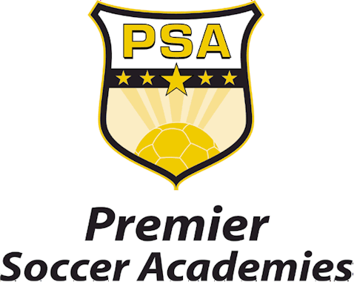

FOR IMMEDIATE RELEASE Contact: Craig Umland,
February 8, 2008 Premier Soccer Academies
440/282-2007
Damian Secore,
BZA-818/462-5614

PSA Announces Complete Roster Of 2008 Soccer Programs And Events

Soccer Camps And Tournaments For All Ages And Skill Levels Now Available For Registration

Lorain, Ohio. - Brad Friedel’s Premier Soccer Academies, the first full-scholarship youth soccer academy in the United States, has officially released its full line-up of 2008 soccer programs and tournaments.

PSA Training Programs

Boys and girls of all ages and skill levels now have the opportunity to learn and train under the direction of some of the best professional coaches in the world.

The PSA Directors (Marc Hottiger, Roy Tunks, and Desmond Armstrong) along with the PSA Academy Coaching Staff, NCAA/NAIA college coaches, and guest appearances from other leading coaches from around the world, will lead the various training programs now available for registration on www.gopsa.com.

(Page 2)

Entry level day-camps, weekend combines, goalkeeping camps, college prep programs, advanced week-long residential and non-residential soccer programs are being offered in several locations around North America with the majority of them being held at the $10 million world-class PSA Campus in Lorain, Ohio.

In all, PSA will provide the opportunity for soccer players to learn from some of the best instructors in a true professional setting and atmosphere that is enjoyable from start to finish.

PSA Tournaments

The PSA National Fever 5 Futbol Tournament features seven (7) regional events in various locations across North America. The national tournament schedule includes events in the following cities such as Los Angeles, Denver, Birmingham, Atlanta, Columbus, Cleveland, and British Columbia. Winners in each age group from each location will have the opportunity to advance to the national finals at the PSA Campus in Lorain, Ohio, on August 23-27, 2008. Complete tournament information and registration is now available by visiting www.gopsa.com.

The PSA World Youth Tournament (August 10-17) will include eight (8) extremely talented U16 teams from around the world. Soccer organizations already accepting invitations include; the Blackburn Rovers (UK) Youth Academy Team, Chivas (Guadalajara, Mexico), a Select Team from the Colorado Rush, and the PSA Academy Team. Tickets are now available at a special rate for all youth players and their families. All remaining tickets will be made available to the general public beginning March 1, 2008. Besides the opportunity to watch some of the best young soccer teams from around the world, players and families attending will enjoy a full compliment of fun activities. For ticket information visit www.gopsa.com.

All proceeds from the many PSA soccer programs and tournaments throughout the year will aide in funding the on-going development of soccer players at the Premier Soccer Academies.

(Page 3)

About Premier Soccer Academies
Located in Lorain, Ohio, Brad Friedel’s Premier Soccer Academies, a not-for-profit 501(c)(3) organization, is the first residential soccer academy of its kind to offer full year-round scholarships to athletes in an effort to develop the next generation of professional soccer players. Each year players from across the globe, ages 12-17, will be recruited based on ability and skill level, not the parents’ ability to pay.

Additional athletic, academic, and health/nutrition programs along with an assortment of different level coaching clinics, will be offered throughout the year targeting all ages and skill levels. Facilities are state-of-the-art and include three and a half soccer fields, indoor fieldhouse, 5,000-square-foot workout facility, student housing and academic learning center. PSA officially opened August 20, 2007 with the arrival of the first class of residency members. PSA’s official website is www.gopsa.com.

# # #

