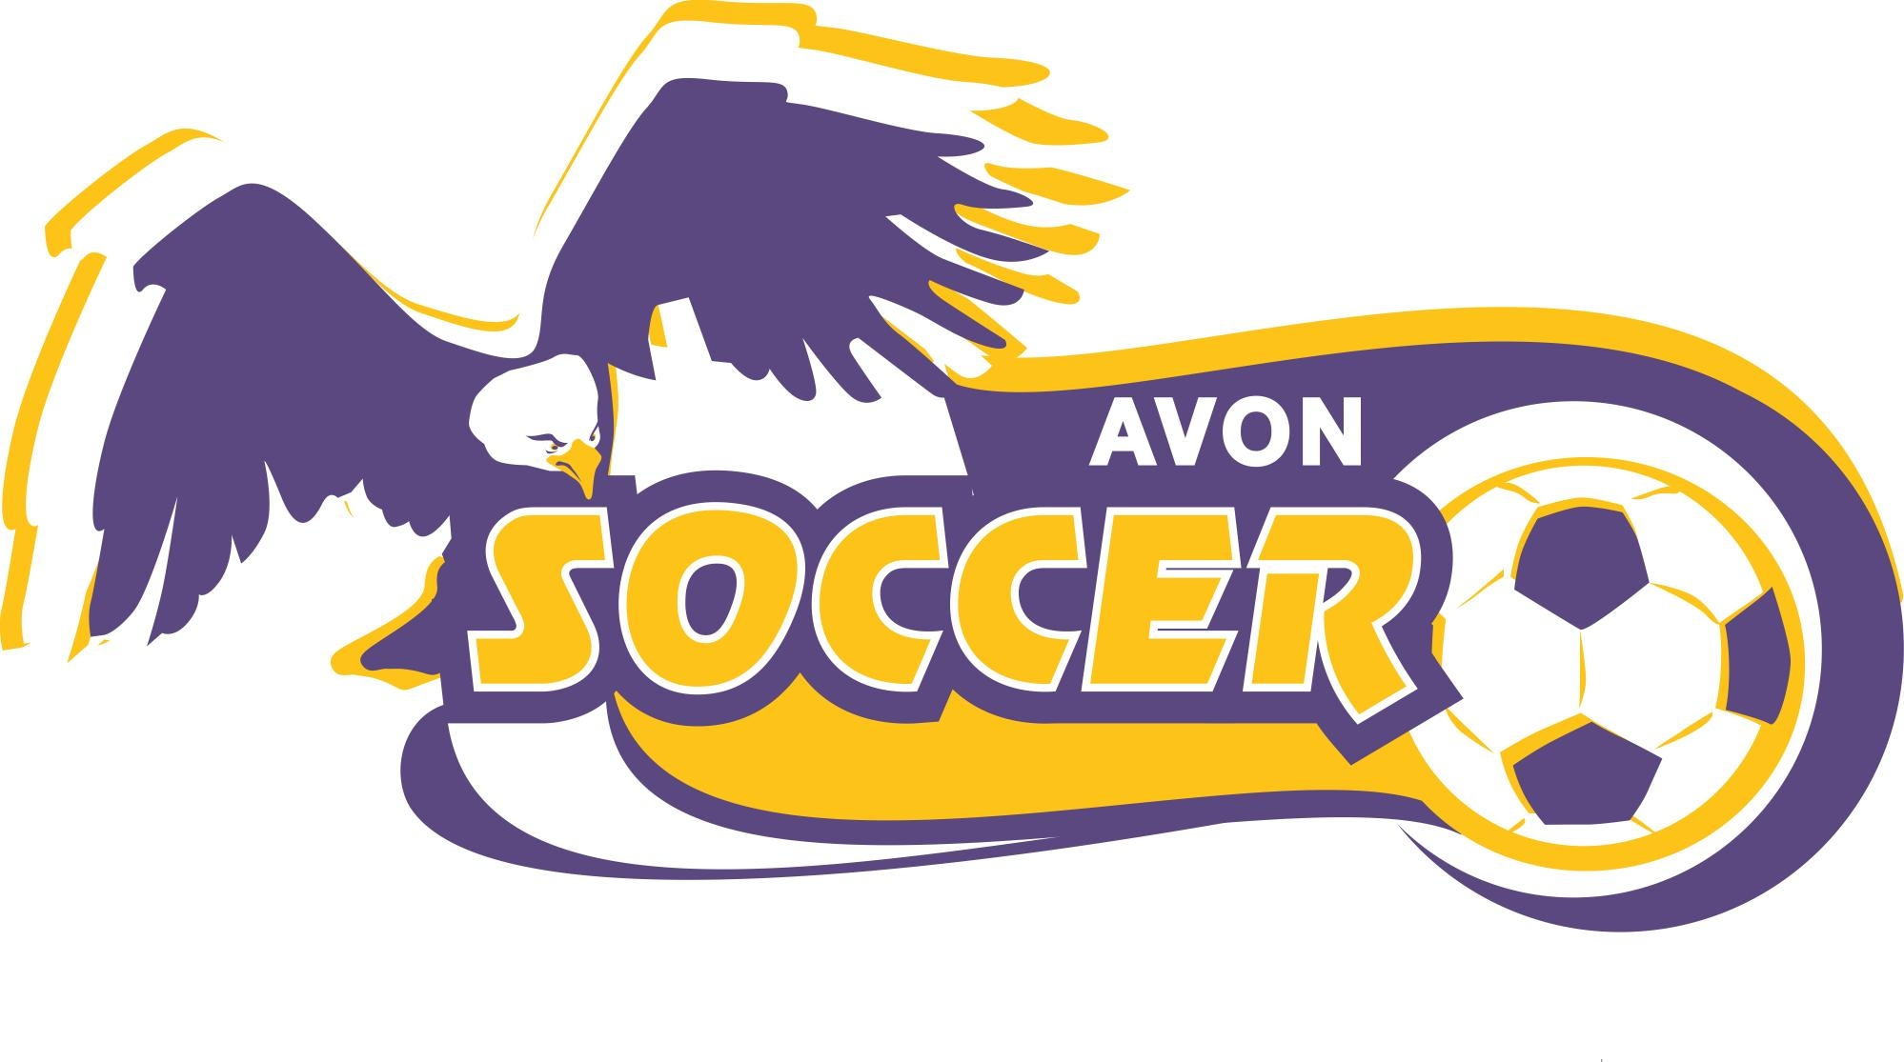

U8 GIRLS DEVELOPMENTAL TRAVEL SPRING 2OO8.

Each year, Avon Soccer League Association offers the Girls U8 age level the opportunity to participate in a developmental travel program that begins in the spring season. This travel league will run from April 27th thru June 1st with an opportunity to participate in the Westlake soccer tournament (for those that want to) Girls that participate also remain on their current recreational team. There are typically 1-2 teams from each community. The team/teams travel only to Avon Lake, Bay, Westlake and North Olmsted and the games are played 9:30 Sunday mornings.

The team/teams will have one combined group practice per week and then one game on the weekend; girls are still expected to attend their recreational team practice and games. If conflicts with times arise, the recreational team is considered the priority. This is a great opportunity to begin preparing the girls for progression to travel at the U9 level, but it is not mandatory that a girl participate in the U8 developmental program to play the following year as a U9 travel player.

Specific information like cost, specific practice times and locations will depend on number of participants but will be very reasonable ($20.00 or less).

At this time we would like to get a response from those who may be interested in the program this spring. You do not need to respond if you have no interest. Please notify Amy Sikora at amysikora@hotmail.com if interested with your name and contact information as well as your daughters name and current recreation coach’s name by February 20th. Any additional questions should also be directed to Amy Sikora who is the U8 girl’s developmental coordinator.

Thank you,
Mike Grudzien
ASLA Travel director.

