AVON SOCCER APPRECIATION SAVINGS!

Dear AVON SOCCER Member:

As a sponsor of AVON SOCCER, DICK’S Sporting Goods values our commitment to your league. As a show of our appreciation for all that you do, we’d like to extend an exclusive offer to save on thousands of sporting goods items throughout our entire store.

Simply bring this letter to DICK’S Westlake or Elyria store locations on Saturday, August 16th, from 1:00pm-7:00pm and you’ll receive an exclusive savings benefit of 15% OFF your entire purchase. This is in addition to your Soccer Team Packet Savings.

We know you’ll enjoy these special savings, where you’ll save big on the top brands for all your sports and recreation activities.

Again, thank you for all your efforts that have helped build our relationship with you at AVON SOCCER!

Sincerely,
DICK’S Sporting Goods
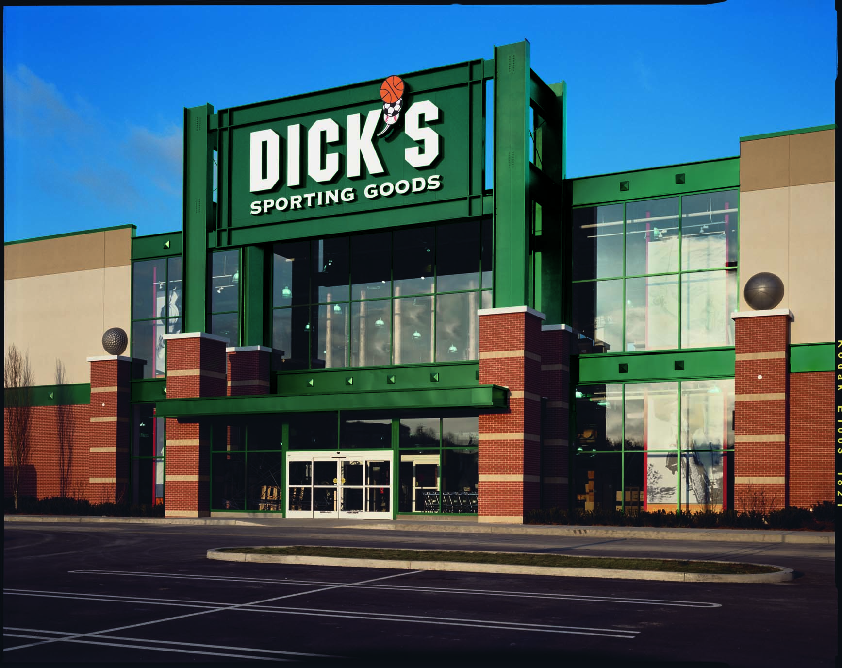

EVERY SEASON STARTS AT DICK’S

Take
15% off
your next purchase

Limit one coupon per customer. Cannot be combined with any other offers, coupons or Guaranteed In-Stock markdown, or used for layaways, gift cards, licenses or previously purchased merchandise. Coupon valid on in-store purchases only. No reproductions or rain checks accepted. Excludes firearms, ammunition, electronics, treadmills, and championship merchandise. Some additional exclusions may apply. See store for details. ASSOCIATE: Scan barcode and take a group discount markdown. Valid only on 08/16/08

