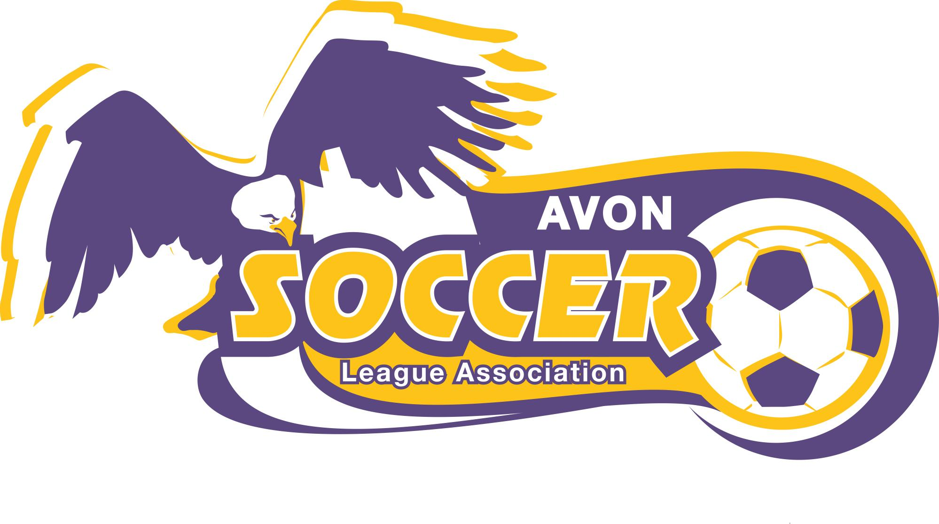

P.A.S.S. - Premier Avon Soccer Schools

Avon Soccer is introducing P.A.S.S. (Premier Avon Soccer Schools) this 2008 spring season. P.A.S.S., open to all rec. players U5, U6, U7 and U8, will provide an opportunity for consistent and accurate soccer skills development.

Chris Dore, AHS High School Varsity Coach, is managing the P.A.S.S. program. Chris has played the game at all levels and will maintain a fun and challenging environment for the players. There will be a number of professional soccer coaches assisting Chris throughout the training process. ASLA also requests all U5, U6, U7 and U8 coaches to attend and participate.

Attention U8 Players and Parents
During spring season the U8 teams will participate in the U8 developmental program managed by Amy Sikora (girls) and Tom Waters (boys). Fall season the U8 players will re-join the P.A.S.S. program.

***Training will be held on Mondays at Schwartz Park***

DATES:

April 7, 14, 21, 28
May 5, 12, 19, 26

TIMES:
U7 5:00 pm - 6:00 pm
U5 6:00 pm - 7:00 pm
U6 7:00 pm - 8:00 pm

ASLA encourages all players to participate in P.A.S.S. This program is part of the overall soccer skills developmental program being introduced by ASLA. See you on the fields!

