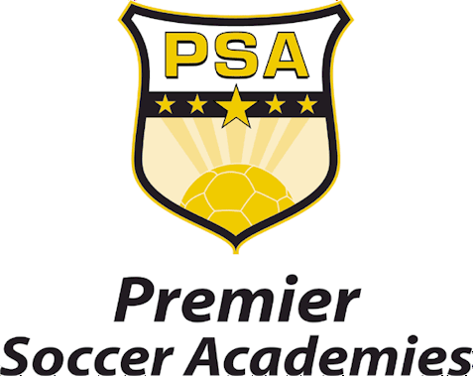

January 2008

Premier Soccer Academies is proud to offer all youth soccer players, their parents, and passionate soccer fans a special opportunity to be part of one of the most exciting youth tournaments to be played in the United States - The PSA World Youth Tournament, August 10-17, 2008.

Eight (8) U16 teams from around the world will compete over eight-days at the PSA Campus in Lorain, Ohio. The eight teams will be placed in one of two groups competing against one another earning three points for a win and one point for a draw. Group A will begin their matches on Sunday, August 10th and Group B beginning on Monday, August 11th. The official draw for the eight teams will take place Tuesday, July 1st.

Each group will have a day of rest between matches. At the conclusion of group play, teams and final weekend matches will be determined based on their points results. All weekend matches are expected to begin around noon and be completed by 4:00 PM. All weekday matches are expected to begin at 4:00 PM and be completed by 8:00 PM. A full compliment of concessions will be made available at the tournament along with fun activities for the whole family. Complete tournament schedules, purchased tickets, and information on parking lot locations will be mailed to you no later than July 15th.

The official opening ceremony will take place on Sunday, August 10th prior to the first match of the tournament and the closing ceremony will take place on Sunday, August 17th following the final match.

Teams already committed to participate in the tournament include; the PSA Academy Team, Blackburn Rovers Academy Team (England), Chivas Academy Team (Mexico), and the Colorado Rush Soccer Club (United States). The four remaining teams will be announced in the coming weeks.

(Page 2)

The quality and rich history of the teams participating will ensure the tournament competition will be of the highest standard. Tickets are limited and will be offered first to all youth soccer players and their parents prior to the general public offering. This is a special opportunity for all young players to see some of the most talented youth teams from around the world compete at the highest levels. Ticket prices and packages are subject to change after March 1st.

If your son or daughter is a current youth soccer player in the United States we ask you to fill out the ADVANCE TICKET ORDER FORM and mail it in promptly with your payment.

On March 1st, any remaining tickets will be offered to the general public so we recommend you respond promptly with your ticket order and payment.

The proceeds from the PSA World Youth Tournament will be used to further the development programs offered at Premier Soccer Academies.

Should you have any further questions in advance of the tournament please feel free to call the Premier Soccer Academies at 440/282-2007.

We look forward to seeing you at the Inaugural PSA World Youth Tournament in August!

Sincerely,

Premier Soccer Academies
Tournament Office
www.gopsa.com

Premier Soccer Academies, 2101 Brad Friedel’s Future Stars, Lorain, Ohio 44053
Phone 440/282-2007 – Fax 440/282-4772

